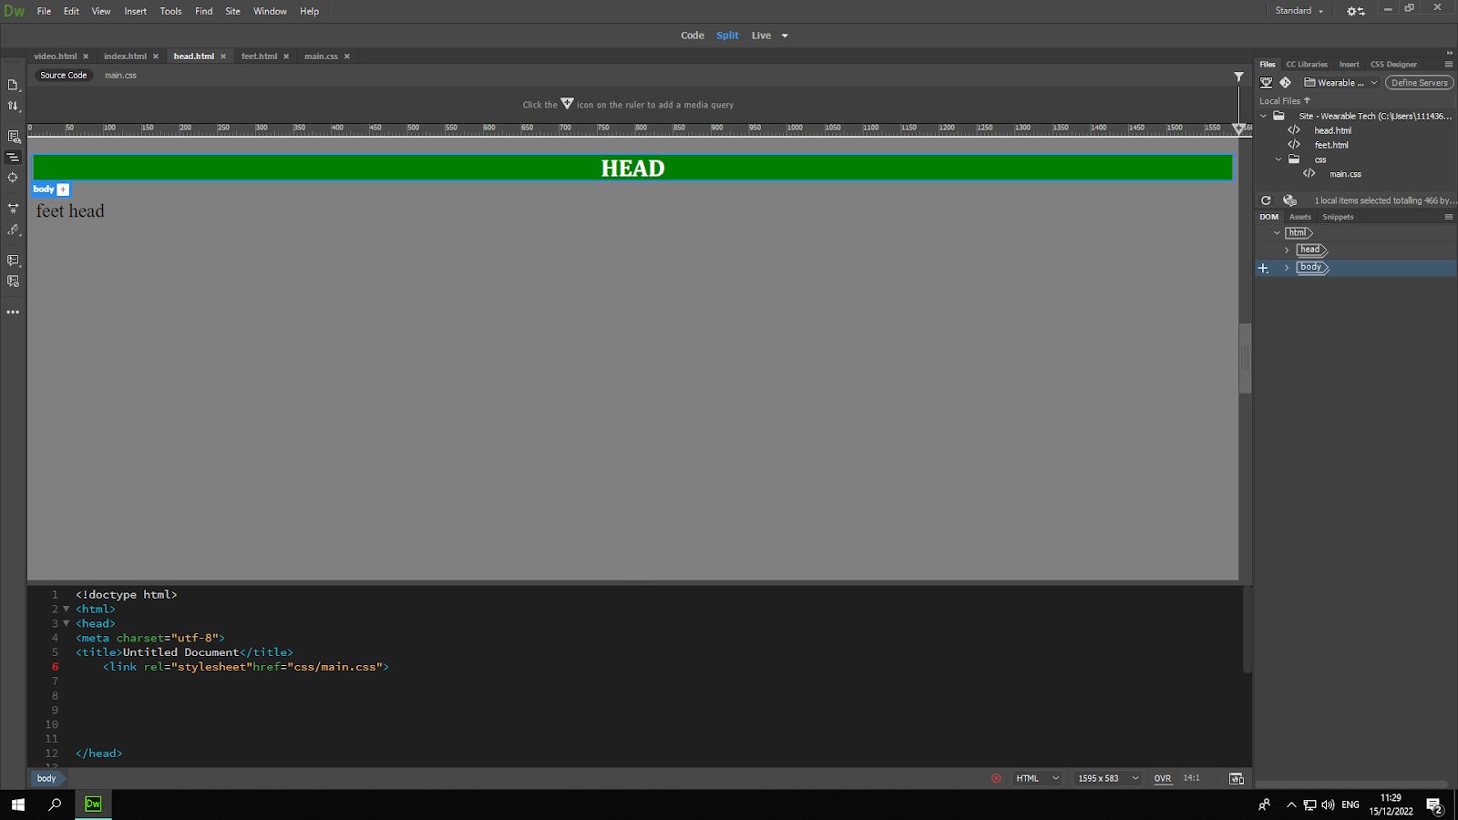

a{display: inline;font-size:25px;text-decoration: none;padding:3px;color:black;float:left;font-family: times new Cambria, "Hoefler Text", "Liberation Serif", Times, "Times New Roman", "serif";}

H1:background color:green;

Color:white;text-align:center;text-transform:uppercase;font-family:times new roman;

Body: background color:grey; ;